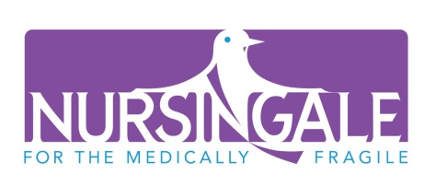

Administrative Specialist

About us:
For the past 13 years, Nursingale has strived to enhance the lives of the medically fragile children and young adults at home and in the community. We support our staff with a generous benefit package and in return, need a candidate with enthusiasm for in home nursing care, honesty, flexibility and integrity.

Job Summary:
- Maintain positive, professional and ethical relationships with referral sources, client families, insurance companies and staff.
- Support Staffing Specialist and HR Manager with filing, creation of reports, tracking of recertification’s and licenses and other projects
- Learn the staffing program for coverage during vacations and when on-call
- Process bi-weekly payroll and make personnel changes in GNSA
- Enter payroll reimbursements into GNSA
- Upload employee’s 401k payroll contributions (bi-weekly)
- Oversee annual renewals for licensure and organizational insurance policies
- Maintain files and notebooks for annual insurance renewals and assist Executive Director as needed.
- Respond to requests for Certificates of Insurance.
- Respond to requests for W9
- Oversee program for annual OHA license renewal
- Assist with social gatherings including the annual TFG event, summer picnic, and holiday parties
- Procure donations for fundraising event and holiday toy drive with KOIN
- Enter donations into tracking program
- Order office supplies
- Have a working knowledge of QuickBooks or willing to learn
- On-call support
30 hours a week
To apply: go to www.nursingale.org, click on Join our Team, print off and complete the Staff Application. Fax application to 503-968-2418, mail to address above, or email to pattis@nursingale.org You may also contact Patti Sadowski, the Executive Director for more information at 503-968-2401.

